Crowhurst C of E Primary School

Spirituality in School Policy


Approved by Governors | 11.6.25
Last reviewed on: | 11.6.25
Next review due by: | July 2028

Spirituality in School

Our vision
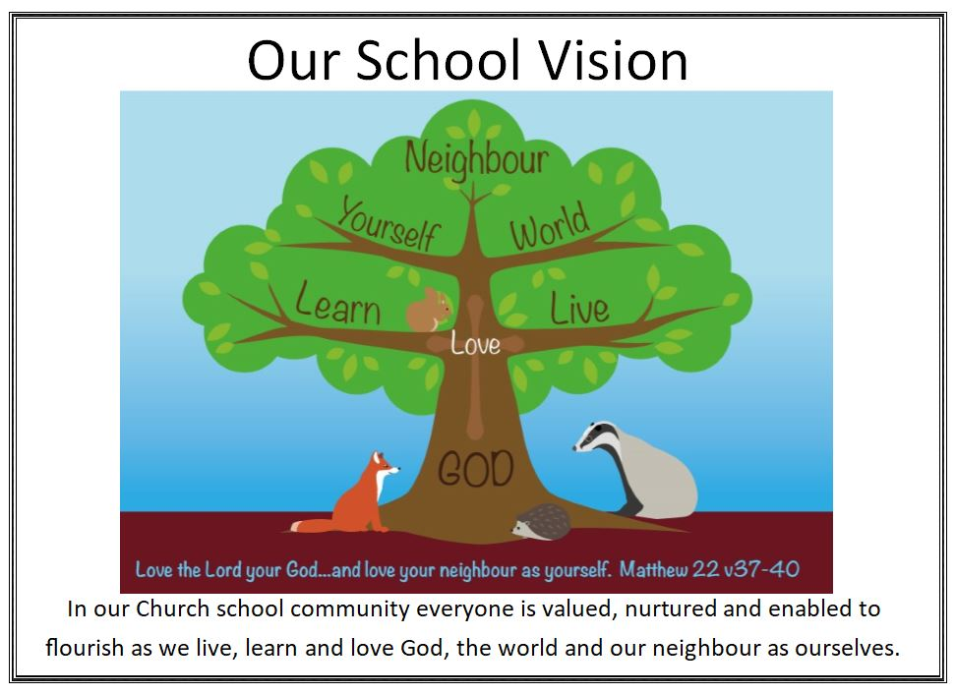

Our vision influences the ethos of our school and the policies and practices within it. We believe that spirituality is a core thread that runs through our school and we attach great importance to it for both children’s development and for the growth and well-being of all within our school community.

We aim for children, and adults, to grow in their ability to:
- be guided by their beliefs and values and be willing to take a stand to defend them
- be self-aware and empathise with the experience of others in the school and wider community
- love themselves, care for themselves, believe in their potential to achieve, and find inner strength and resilience when facing challenges
- exercise imagination and creativity, appreciate beauty in the world and be alive to experiences of awe and wonder
- be intrigued by mystery and be open to an awareness of the transcendent in the whole of life
- be comfortable with stillness and silence and open to engage in reflection/meditation/prayer
- be ready to say sorry when mistakes are made, to forgive themselves and to forgive others
- be willing to take risks and to reflect, learn and grow following experiences of failure as well as success
- demonstrate curiosity and open mindedness when exploring life’s big questions
- appreciate and be thankful for what is good in life like friends and family, and show generosity towards others

(From David Smith’s work on Spiritual Capacities)

Our working definition of ‘spirituality’

Spiritual development is the development of an awareness that there is “something more to life than meets the eye, something more than the material, something more than the obvious, something to wonder at, something to respond to.” (Terence Copley)

Legal requirements:
Section 78 of the Education Act 2002 states:
The curriculum for a maintained school or maintained nursery school satisfies the requirements of this section if it is a balanced and broadly-based curriculum which: (a) promotes the spiritual, moral, cultural, mental, and physical development of pupils at the school and of society, and (b) prepares pupils at the school for the opportunities, responsibilities and experiences of later life.

The SIAMS Framework (amended September 2024) references spirituality and spiritual development within Inspection Question 2 – ‘How does the curriculum reflect the school’s theologically rooted Christian vision?’ and Inspection Question 3 - How is daily collective worship enabling pupils and adults to flourish spiritually?’ The Church of England Vision for Education has a core desire for ‘Life in all its fullness’ (John 10:10) which requires educating the whole person.

The OFSTED framework 2024 states that pupil’s spiritual development is shown by their:
- ability to be reflective about their own beliefs (religious or otherwise) and perspective on life
- knowledge of, and respect for, different people’s faith, feelings, and values
- sense of enjoyment and fascination in learning about themselves, others, and the world around them
- use of imagination and creativity in their learning
- willingness to reflect on their experiences

We support pupils in their spiritual development by:
  - providing opportunities for spiritual development in collective worship
  - providing opportunities for spiritual development in RE
  - providing opportunities for spiritual development in the wider curriculum
  - capturing opportunities for awe and wonder as they arise
  - providing ‘Sacred Spaces’ in classrooms, public spaces, outside, and by using the church building, and through the ‘Prayer Spaces in School’ website
  - offering pupils opportunities to develop their own spiritual leadership, through leading collective worship and other opportunities

As a staff team:
  - We have a staff understanding of spiritual development.
  - We have a culture within our school that recognises the importance of spirituality to individuals, both children and staff.
  - We revisit spirituality as an area for consideration in our staff meetings and offer training.
  - Our governors monitor the impact of our spirituality focus.
  - We ensure new staff are aware of our school policy on spiritual development.
  - We use models to support our own thinking in spirituality, such as the ‘Windows, Mirrors, Doors, Candle’ approach.
  - We have a variety of spiritual spaces both inside and outside the school building.
  - We are aware of spiritual development shown across four key areas of Self, Others, Beauty and Beyond (Andrew Rickett / Rebecca Nye).
  - We recognise that children will have different ‘Spiritual Temperaments’ or ‘Sacred Pathways, through the work of Gary Thomas (2010) and Myra Perrine (2007). This will influence our planning as we look to nurture spirituality across the curriculum, not just in RE and Collective Worship.
  - We use the ‘Ricketts Grids’ to support our understanding of progression in spiritual development in these four areas of Self, Others, Beauty and Beyond.
  - We actively use the language we have agreed on with staff to nurture an awareness of spirituality and its importance to well-being and development with the children.
  - We aim to help each pupil to develop a spiritual understanding in terms of their own cultural context.
  - We share with parents, whenever possible, the outcomes of our focus on spiritual development through newsletters, social media, displays and our website.
  - We discuss spirituality with our church and others who can further support this thread.

Our awareness and understanding of spiritual development will enrich what we offer to the children and to all in our school community.

Other related policies:
Collective Worship
Teaching and Learning
Relationships and Behaviour
SMSC
All subject specific curriculum policies – especially Religious Education

Referenced reading:
Church of England Education Office (CEEO) Spiritual Development – Interpretations of Spiritual Development in the Classroom (2019)
https://www.bathandwells.org.uk/supporting-children/school-effectiveness/recollective-worship-and-spirituality/spiritual-development/

