Crowhurst CE Primary School
Special Educational Needs Information Report 2023


In our Church school community, everyone is valued, nurtured and helped to flourish as we learn, live and love God, the world and our neighbours as ourselves.
About this report
The Children and Families Act 2014 says that all maintained schools must publish a Special Educational Needs (SEN) Information Report every year. This report explains how our school meets the needs of children with SEN. It will be shown on our school website and in the ‘local offer’ on www.eastsussex.gov.uk
In the report, we explain how we meet our duties towards pupils with special educational needs and disabilities. This report links to our SEND policy. For more information on the law and guidance we follow, see www.eastsussex.gov.uk/localoffer
We will review this report regularly to keep it up to date. The governing body will review it annually and we will involve parents and pupils. If you want to give us feedback about this report, please contact the school office.

Who should I contact?
If you are thinking of applying for a place for your child, contact the school office on 01424 830324 or via email office@crowhurst.e-sussex.sch.uk
We encourage and welcome prospective families to visit the school.
If your child is already at the school their class teacher is your first point of contact. You can speak to them briefly at the end of the school day when they dismiss the class or leave a message with the school office and they will contact you to arrange a time to meet.
The Special Educational Needs Coodinator (SENCO) is responsible for managing and co-ordinating the support for children with special educational needs, including those who have Educational, Health and Care Plans (EHCP). The SENCO also provides professional guidance to staff and works closely with parents and other services that provide support for children in the school.
SENCO: Miss Debbie Mears, currently the role is being covered by Mrs Suzanne Cleverley
Days in school: Friday
Contact: senco@crowhurst.e-sussex.sch.uk
Telephone: 01424 830324
Which children does Crowhurst C of E School provide for?
We are a voluntary controlled Church of England primary school and admit pupils from age 4 to 11. We provide a nurturing environment where all children are valued and encouraged to flourish. Crowhurst is a small rural school primarily serving the village of Crowhurst and the surrounding area, we do have some families who travel from Battle, Bexhill-on-Sea and Hastings. Our classes are taught in mixed year groups. Currently we have:
Class |  | Year Groups
 | Hedgehogs | Reception and Year 1
 | Squirrels | Year 2
 | Foxes | Year 3 and 4
 | Badgers | Year 5 and 6

We are an inclusive school, this means we provide for children with all types of special educational needs. If you want a place for a child with an Education Health and Care plan contact your Assessment and Planning Officer at East Sussex County Council and ask for this to be considered as part of the annual review process. If you want a place for any other child with special educational needs, you should apply as normal and your application will be considered in the same way as applications from children without special educational needs.
For further information please:
- Visit our admissions page Crowhurst CofE Primary School - Admissions
- Contact school admissions Apply for a school place | East Sussex County Council
- Contact ‘Information for Families’ for admissions advice 0345 60 80 192

Summary of how Crowhurst C of E School meets the needs of children with SEN and Disabilities
We are committed to meeting the needs of all of the pupils within our school including those with special educational needs. We have a whole school approach which is embedded in delivering high quality teaching to every child with adaptations and suitable differentiation to enable all children to access the curriculum, learn and progress.
We aim to match provision and resources to the individual presenting needs of children. To support this we use the graduated, cyclical approach of Assess, Plan, Do, Review
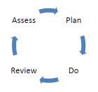
Assess
All children’s progress is monitored and carefully assessed by teachers, teaching assistants and senior leaders. This enables us to look at what is working well and what needs changing as well as helping identify any additional needs.
The assessment takes a number of forms; which are outlined in more detail in the next question and answer. We also hold regular pupil progress meetings where leaders meet with teachers to discuss the progress of individual children and plan next steps. Assessments may also come from external professionals such as Educational Psychologists, CAMHS (Child and Adolescent Mental Health Services, Doctors, Occupational Therapists, Speech and Language Therapists, Family key workers and others.
Plan
Following assessments a plan is put in place for any children who are not making the progress we would expect or who have been identified as having a Special Educational Need or Disability (SEN/D). The child may be placed on the school SEN register. There is a graduated approach to the planning that is used at Crowhurst which is in line with East Sussex guidance. The SENCO will provide support and guidance to teachers and parents on the planning and provision for children. Pupils will be included throughout the process and ‘pupil voice’ will be included.

Monitoring Plan
Initially we may choose to monitor a child more closely and record the strategies that we are using over a period of time. This allows all involved to focus in on what is working, gather more evidence and try different approaches. A monitoring plan may be appropriate when:
- A child is new to the school and requires time to settle in before deciding if they need more intensive/structured support
- The change in progress is only minor
- A child has been on the SEN register and has now been removed as they are making good progress but we wish to monitor for a period of time
- There is a new concern but we need to gather more evidence
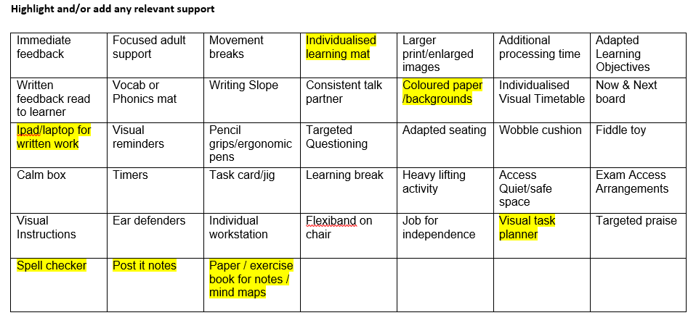
Example of part of a monitoring plan
APDR Plan
An APDR (assess, plan, do, review) Plan is put in place if a child has been identified as having SEND needs, at this point they will be placed on the school SEN register. APDR Plans are produced by the class teacher (with SENCO support) in collaboration with parents and pupils. The plan will include information on the child’s strengths, areas of interest, key relevant information including assessment data and set focused targets and provision.
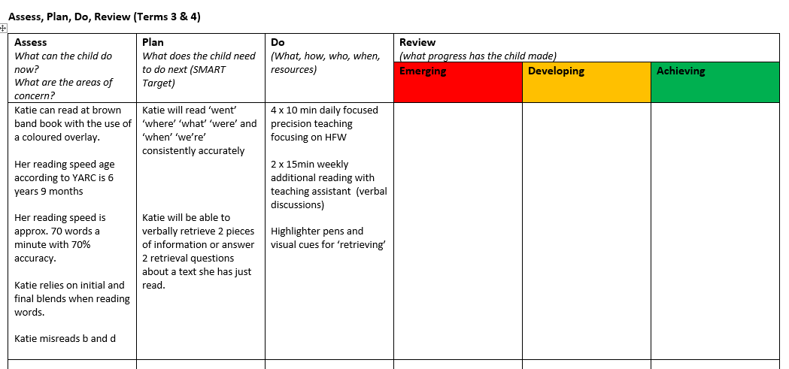
Example APDR Targets and provision
Additional Needs Plan (ANP)
Some children have more complex needs and have other professionals working with them, they will require a more detailed Additional Needs Plan (ANP). This is similar to the above plans but includes more information about areas of need and longer term targets.
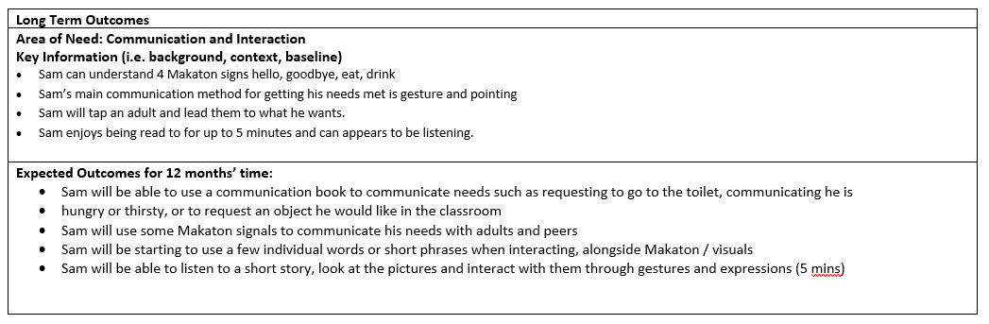
Example ANP area of need and outcomes
Education, Health and Care Plans (EHCP)
A small percentage of children with highly complex needs may require an Education Health and Care Plan (nationally approximately 4% of children). If parents or school feel and EHCP is needed they will request a statutory assessment from the local authority (East Sussex) who will then decide whether to issue an EHCP. More information about the statutory assessment process and EHCPs can be found here Education, Health and Care Plans | East Sussex Local Offer
Care Plans/PEPs
If a child is looked after by the local authority (such as being in foster care) they will have a Care Plan which includes a Personal Education Plan (PEP) and Health Plan. We will coordinate these plans with an Additional Needs Plan and involve social workers, the virtual school, parents, foster carers and children in the discussions as appropriate. More information about The Virtual School (who oversee the education of looked after children in schools) can be found here The Virtual School for Children in Care | East Sussex County Council
Do
- The targets and provision agreed in the plans are implemented under the guidance of the teacher and SENCO.
- Class teachers maintain responsibility for the learning and progress of all pupils in their class and ensuring that learning is adapted so pupils with SEND are included and able to make progress.
- All people working with the child will be made aware of their needs and adapt their support accordingly.
- Teaching assistants are often the staff who work closely with SEND pupils, providing in class support and small group interventions.
- The teacher, SENCO and leaders will ensure Teaching Assistants are provided with appropriate training, resources and time to deliver support to a high standard.
- School will work with other professionals and specialist support services as necessary
- Consideration will be given to changes in timetables and routines to ensure all SEND pupils are accessing a broad and balanced curriculum (for example they do not always miss PE to have additional phonics support)
- Where appropriate and financially possible additional resources may be purchased to support a child such as:
  - Sensory ‘sit and move’ cushions
  - Ear defenders
  - ICT programmes or Apps
  - Weighted blankets
Review
Children’s progress is reviewed as part of an ongoing process across the whole school.
APDR Plans and ANPS are reviewed at least 3 times a year. Parents are included in this review process. This may be via parent/teacher consultations, sharing targets and inviting feedback and face to face review meetings with class teachers and the SENCO.
If a child has an EHCP one of the yearly reviews will be an ‘Annual Review’ meeting. These meetings are in place to ensure the EHCP is still accurate. Parents, pupils, school and all other professionals involved are invited to contribute to the meeting. Annual review meetings must be submitted to the Local Authority and form part of the statutory process.
If at any stage throughout the Assess, Plan, Do, Review cycle a child is not making the progress we would expect then they can be moved up a stage. This may include making referrals to specialists such as Speech and Language or Occupational Health Therapists or seeking advice from ISEND services (these are explained in more detail later in this report).
If at the review process a child has not made the expected progress despite significant support from within school and from outside professionals, consideration will be given to submitting a statutory assessment request for an EHCP. This request can come from school or parents. If the school decides to request assessment it will be in discussion and agreement with other professionals and parents.
The Local Authority will decide if a statutory assessment (sometimes called an EHC needs assessment) is needed. To inform their decision they will carefully consider the actions and provision already implemented by the school to support the child’s needs and measure this against the ‘East Sussex SEN Matrix’ to decide if school has used all available resources and strategies that would be expected for SEND pupils. Following an EHC needs assessment the local authority decides if a child is issued with an Education, Health and Care Plan. Please be aware that agreement to assess does not guarantee an EHCP.
How does Crowhurst C of E School identify children’s special educational needs?
A pupil has SEN where their learning difficulty or disability calls for special educational provision. That is provision which is different from or additional to that normally available to pupils of the same age.
Children may have one or more broad areas of special educational need:
• Communication and interaction – including speech and language difficulties and autism
• Cognition and learning – including developmental delay and specific learning difficulties such as dyslexia, dyscalculia and dyspraxia.
• Social, emotional and mental health difficulties – including difficulties with behaviour, attention deficit hyperactive disorder, an attachment disorder or anxiety.
• Sensory and/or physical needs- including visual and hearing impairment, dyspraxia, cerebral palsy and other physical disabilities or medical conditions which affect a child’s learning.

Early Years
We aim to identify children’s special educational needs (SEN) as early as possible, so that the child achieves the best possible outcomes, the reception team work closely with pre-schools and nursery to identify any children who may need additional support when starting at Crowhurst, staff visit the nurseries and children at home to gather as much information as possible. Examples of ways we have identified children in Early Years include:
- Additional transition visits
- Having joint planning meetings with nursery staff, school and parents to plan small step targets for starting school
- Joint working with early years professionals from agencies such as Speech and Language, Occupational Therapy and the ISEND Early Years Team
In addition to this all children’s skills and attainment are assessed when they start school to provide a ‘baseline’. We then continually assess children throughout reception using a range of resources and observations, if a child does not make the progress we would expect from them in relation to their age we would consider if they have any special needs, this will always be done in consultation with parents and carers as well as with the school SENCO.
All children in reception are screened using Language Link Parent Portal | Home (speechandlanguage.info), any children who struggle with speech will also be screened using Speechlink.
Key Stage One and Two
Throughout their time at Crowhurst children are continually assessed both formally and informally. This may take the form of:
- Observations during lessons and playtimes
- Marking work
- Questioning
- In-house tests
- Regular assessment papers that provided standardised scores
- Phonics assessments
- Statutory testing
  - Year 1 phonics screening
  - Year 2 SATS
  - Year 6 SATS

These assessments along with teacher judgements and parental concerns help us to build a picture of a child and decide if they have SEN. If a teacher or parent has concerns they can raise these with the SENCO who may carry out further observations and assessments such as:

- A dyslexia screening test (for children over 7 years)
- Junior Language Link
- Pupil Voice
- Boxall profile
- Thrive assessment
- Referring to other professionals
Using all the evidence available a decision will then be made whether to place the child on the school SEN register.
How does Crowhurst C of E School teach and support children with SEND?

At Crowhurst, our aim is for pupils to develop the knowledge and skills to be successful, independent, collaborative and motivated learners, helping them to develop the qualities they need to succeed and enjoy happiness in life.
We are very proud of our rich and varied curriculum which caters for every child’s needs. We are confident that it enables pupils to not only excel in reading, writing and mathematics, but also develops their knowledge, skills and understanding across a wide range of subjects.
All children benefit from high quality, differentiated learning but some pupils who have SEND require ‘additional to or different from this’ and we use our ‘best endeavours’ to ensure we provide this. (SEN Code of Practice 1.24).

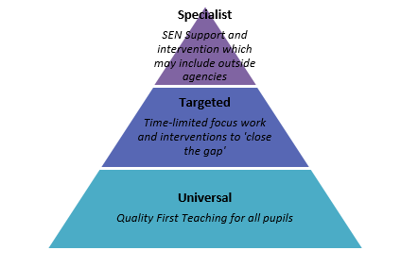
Support given will depend on the area and severity of need and may include:
- Further differentiation within the class through levels of work and supporting apparatus.
- Pre-teaching to prepare children and allow them to process information.
- Small group work/intervention, e.g. phonics groups, nurture groups, social skills groups, motor skills groups, language groups within the capacity of the school.
- Individual interventions to support reading, writing and maths.
- Individual timelines to support children with school routines
- Individual apparatus or resources such as: reading overlays, use of iPad or laptop for writing, sensory equipment.
- Visual prompts used by adults to support children.
- Additional adult support within the capacity of the school, this usually entails the class teaching assistant being directed by the teacher to support specific groups of children within the class.
- Support from outside agencies.

You can find out more about the Universally Available Provision here: SEND Support at School (Universally Available Provision) | East Sussex Local Offer

How will the curriculum and learning environment be matched to the child’ needs?
The identification and support for pupils with SEND is strong. School leaders have trained staff in areas such as emotional literacy, to make sure that pupils with SEND are supported both in class and when at play. Teachers adapt lessons to support the needs of pupils. As a result, pupils with SEND can learn the same curriculum as their classmates.
Ofsted March 2022

All pupils have access to a broad and balanced curriculum. High expectations are at the heart of our school and are set for all. Every child is supported to fulfil their potential and to have the emotional well -being needed to be aspirational. We adjust the curriculum for each child with SEN to make sure that they can access the subjects at their own level and make progress. This is called ‘differentiation’.
Teachers ensure that their classrooms are organised to be inclusive for all and make any necessary adjustments to meet the needs of the children. This might be by arranging seating to suit particular needs, providing a range of resources that children can independently access or having working walls that provide key information for pupils linked to current learning.
At Crowhurst we are lucky to enjoy a quiet, rural setting, surrounded by farm land and opposite the Church. Our grounds provide plenty of opportunity for learning outside and quiet spaces for children to access if they need space to regulate their emotions. We have two small rooms that can be used for additional group teaching if needed.
The main part of the school building is the original school house and as such isn’t fully accessible for children and adults with mobility issues. We do not have a disabled toilet within the school building but are able to access the disabled toilets within the village hall that Crowhurst School uses throughout the school day.
We would encourage any parent who has a child with accessibility issues to visit the school and assess the suitability of the environment. We would look to work with parents, children and where appropriate East Sussex County Council to make any adaptations that are suitable and possible within the restraints of our setting.

How are parents and carers involved in reviewing children’s progress and planning support?
At Crowhurst we recognise that the most effective learning occurs when school and families work together. We have an excellent tradition of parental engagement. We are committed to forming positive relationships with all parents and view them as an integral part of our school community, welcoming them to many school events. Parents and carers are encouraged to liaise with their child’s class teacher both informally and formally. Should they need to raise a concern or share a success they are welcome to approach the class teacher in the first instance.
For children with SEN, parent’s views are listened to and actively sought as they form an important part of the review and planning cycle. Teachers and /or the SENCO will meet with parents three times a year to review and plan next steps in children’s progress. As mentioned above, an APDR form will be used to set out targets and support. For children with higher levels of need, an Additional Needs Plan will be put in place, again parents are integral to the process and meet with the SENCO and class teacher to agree and review the plan.
For children with an Education and Health Care plan there will be a statutory Annual Review which will form one of the three yearly meetings
Parents are encouraged to be in in regular contact with the key people and should not wait until a planned review should they have a concern. Meetings with the SENCO can be arranged via the school office.
As well as these meetings there are regular parent/consultation meetings and an annual school report.

How are children involved in reviewing their progress and planning support?
Pupils are involved in reviewing their progress and support in ways that are developmentally appropriate for them. Below are some examples of ways that pupils may be involved.
 | Who’s involved? | How often?
Self-Assessment | Pupil, class teacher, Teaching assistants | Daily
Class Circle Time | Pupil, class teacher, Teaching assistants | As needed and opportunity arises
Worry Boxes, Suggestion boxes | Pupil, teachers, leaders | As needed
School Council | Class, teachers | As needed
SEND Review meetings | Pupil, families, teacher, SENCO, outside agencies | At least three times a year
Pupil Voice | Pupils, Teacher, Teaching Assistant, SENCO | As needed

How does Crowhurst C of E School prepare and support children to transfer to a new setting or the next stage of education and life?
Nursery to Reception
At Crowhurst we work closely with our local nursery schools to ensure children have the best possible transition into school. This includes staff visiting the children in their nursery and pre-school settings and meeting with nursery staff to ensure all relevant information is passed on. New children are invited into ‘taster’ sessions in the summer term and there is a staggered start in September. For those children with SEND needs or who may find starting school more difficult the SENCO may liaise directly with nursery settings and families before the child starts in reception, additional taster sessions may be offered and children may have an longer staggered start.
Some children start school with an ANP or EHCP and in those cases support from the ISEND Early Years’ Service is sought to provide additional advice and guidance to ensure as smooth a start as possible to a child’s time at Crowhurst.
Moving Classes
As a small school we pride ourselves on knowing our children well regardless of which class they are in and most children stay with the same teacher for two years. Despite the familiarity most children have with the whole school community we recognise that moving from one class to another can be difficult and that children with SEND can often find any change challenging and anxiety inducing. In the summer term children spend time in their new classes, getting to know the room, teacher and teaching assistant. Some SEN pupils may spend more time in their new class to allow them to feel comfortable and settled when they start in the September. If necessary children who are highly anxious about change can come into school on the INSET day before starting in September to remind themselves of their new classroom, find their peg and say hello to their teacher before the rest of the school return.
Teachers meet to share information and discuss individual pupils prior to starting a new year group. The SENCO ensures all provision and resources are in place for the start of the new academic year.
Moving to Secondary School
Throughout year 6 we are preparing children for moving onto secondary school. All year 6 pupils take part in Taster Days (normally 3 days) at their chosen secondary schools. For pupils with SEND and those who may find starting secondary school more difficult there are additional taster days. On these days the children will go with a member of Crowhurst staff and have a chance to see the school SENCO, pastoral staff and any resources or rooms that they may access. We work closely with all our local secondary schools.
For all pupils the class teacher will share information with the secondary schools about achievement, progress and behaviour. For those children with SEND the SENCO will meet with the appropriate staff (normally the SENCO or Year 7 Lead) to share information about the child, including strengths, areas for development and strategies. All SEND paperwork and plans transfer to the secondary school to ensure continuity.
If a child has an EHCP then an annual review in the summer term of Year 5 will be held to discuss secondary options, the Assessment and Planning Officer form the local authority is invited to this meeting. This is to allow time for the EHCP to be reviewed and amended for the next phase of education

Support Materials
We use the ‘Moving On’ transition materials provided by CLASS to support children as they move from one phase to another. This may be as a small group intervention in terms 5 and 6. The booklets help children to work through any worries they may have about starting secondary school.
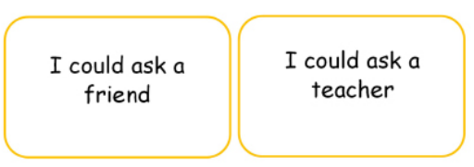
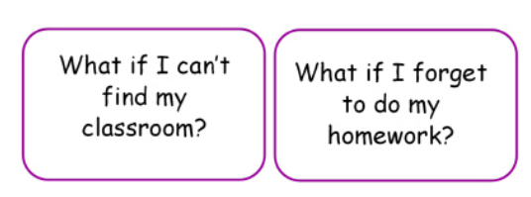
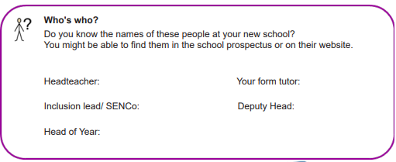
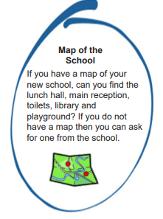

Examples of Resources from the ‘Moving On’ Materials

What training do the staff have?
When we plan support for a child, we think about eh knowledge and skills their teachers and support staff will need. If necessary, we plan training for staff members or arrange an INSET day.
- All of our teachers are fully qualified
- The SENCO holds the National Award in Special Educational Needs
- Our teaching assistants receive continual professional development
- All staff undertake regular safeguarding training
Our staff have a wide range of skills and training relevant to SEND pupils, different members of our team have been trained in:
- Autism awareness
- Speech and Language support
- Sensory Circuits
- Jump Ahead
- Thrive
- ‘Bucket Time’ interventions
- Nurture and carrying out Boxall Profiles
- EBSA (Emotionally Based School Avoidance) awareness
- Phonics support
- Mental health and wellbeing support
- Dyslexia support and carrying out Dyslexia screening tests
We have access to a wide range of training and are constantly seeking to improve our understanding and knowledge.
How does Crowhurst C of E School measure how well it teaches and supports children with SEND?
We regularly and carefully review the quality of teaching for all pupils to make sure no one under achieves. We do this through a cycle of:
- Monitoring
- lesson observations
- book looks
- talking to children
- pupil progress meetings
- internal assessments
- statutory assessments
Interventions are monitored and their impact measured to ensure we are delivering effective support to SEND pupils.
There is a cycle of self-evaluation that then informs the SEND action plan.
We also invite parents and carers to provide feedback at meetings and through the Ofsted parent view website Welcome to Ofsted Parent View | Ofsted Parent View
How accessible is Crowhurst C of E and how does it arrange equipment or facilities children need?
Crowhurst is made up of the original Victorian school house and two newer classrooms which are separate to the main building. The age of the main building means it may not be fully accessible for children and adults with mobility issues. We do not have a disabled toilet within the school building but are able to access the disabled toilets within the village hall that Crowhurst School uses throughout the school day.
We would encourage any parent who has a child with accessibility issues to visit the school and assess the suitability of the environment. We would look to work with parents, children and where appropriate East Sussex County Council to make any adaptations that are suitable and possible within the restraints of our setting.

How are pupils with SEND included in activities with other children, including school trips?
Through careful planning and reasonable adjustments, pupils with SEN engage in the activities of the school together with those who do not have SEN and are encouraged to participate fully in the life of the school and in any wider community activity.
We work with parents and pupils to listen to their views, feelings and wishes to ensure pupils with SEN engage fully in the life of the school and in any wider community activity.
On occasions a specific risk assessment for a school trip will be written and discussed with parents to support their child to successfully participate with the planned activity.
What support is there for children’s overall well-being and their emotional, mental and social development?
As a small school we are able to get to know our children and families well, enabling us to truly nurture and value each child, recognising their unique strengths and challenges. We aim for all children to be equipped with the tools to help them manage their own well-being and emotional development as they progress through the school and on to their next stage of development.
The school uses a variety of day to day support strategies for children to enable them to feel nurtured and manage their well-being, these include:

- A member of staff is always on the school gate in the morning to welcome children into school
- Members of staff are readily available for pupils who wish to discuss issues and concerns
- Small group interventions and support are available such as nurture, thrive and emotional regulation groups with trained staff
- Access to calming ‘boxes’ or spaces within the classroom
- Support is available for children who struggle with play and lunchtimes
Neuro Ninjas
In addition to these we also use the Neuro Ninjas programme which is a whole school programme based on neuro-science and research that explicitly teaches all children about their brain and understand how to develop skills to manage their well-being.
The programme encourages children (as well as staff and families) to practice ‘The 12 Rocks of Well-Being’ every day.
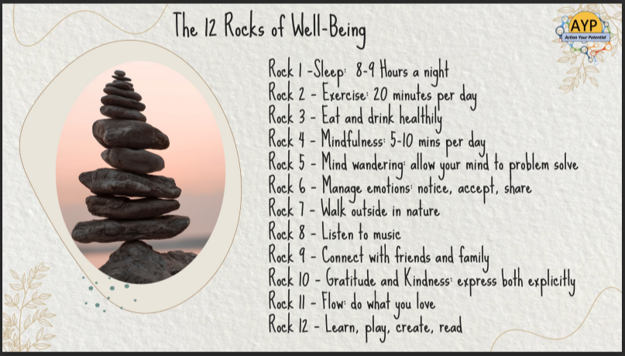

As part of the programme individual children are able to access 1:1 coaching to support them manage their well-being and develop resilience, skills and strategies.
You can find out more about the Neuro-Ninjas programme here HOME | ActionYourPotential

What specialist services does Crowhurst C of E School use to support children and their families?
As part of the cycle of SEN support (assess, plan, do, review) we will consider whether we need to involve other services to make sure the child’s specific needs are met. Parents are always involved in any decision to involve specialists.
Below is a list of services we have referred to or consulted with:
- East Sussex ISEND services
  - CLASS (Communication, Learning and Autism Support Service)
  - ESBAS (Education Support, Behaviour and Attendance Service)
  - EALS (English as an Additional Language Service)
  - EPS (Educational Psychology Service)
  - TLP (Teaching and Learning Provision)
  - GRT (Gypsy, Roma and Traveller Provision)
  - EYS (Early Years Service)
  - SNS (Sensory Needs Service)
- Occupational Therapy
- Physiotherapy
- Speech and Language Therapy
- Local Hospitals – Paediatricians
- CAMHS (Child and Adolescent Support Team)
- Children’s Services
- Early Help keyworkers
- Family Support Workers
- Dragonflies (Bereavement counselling)
- Fellowship of St Nicholas
You can find out more about the services available in East Sussex via the Local Offer East Sussex Local Offer
Where can I get information, advice and support?
East Sussex Local Offer
The Government asks that all local authorities (in our case, East Sussex County Council) provide information as clearly as possible so that parents, carers, children and young people can make informed decisions.
The East Sussex Local Offer consists of an information site which outlines how different SEND processes work and what support is available for children and young people with SEND, and their families. East Sussex Local Offer
It also includes a SEND-specific directory listing local and online services, which you can use 'Local Offer' for Children & Young People - East Sussex 1Space.
Visit the East Sussex Local Offer website at: East Sussex Local Offer

Amaze
Amaze is a charity that gives information, advice and support to families of children and young people with special educational needs and disabilities living in Brighton and Hove and East Sussex. You can find out about their services here: For families with disabled children and young people in Sussex - Amaze (amazesussex.org.uk)

SEND Information, advice and support service
For impartial advice and support for children and young people with special needs and their families you can contact the SENDIASS advice line on 01273 772289 or find out more information here: Amaze - SENDIASS advice line for families with disabled children in Sussex (amazesussex.org.uk)
Community Integrated Therapies and Equipment (CITES)
CITES are a 100-strong team of qualified occupational therapists, physiotherapists, speech and language therapists, assistants and administrators who provide non-acute therapy to children and young people living in East Sussex. Visit CITES at: Children’s Integrated Therapy and Equipment Service | East Sussex (eastsussexchildren.nhs.uk)
Communication, Learning, Autism Support Service +
CLASS+ works across East Sussex to support families/carers of Autistic children and young people. Their aim is to provide guidance and training that enables families/carers to build their understanding of the strengths and challenges faced by Autistic children and young people and to develop greater confidence in how to support them.
Find out more information about CLASS+ at: ISEND CLASS+ - East Sussex 1Space
i-go
i-go is the East Sussex Children and Young People’s Additional Needs Register and free leisure discount card. The card is available for those aged 0-25 with additional needs living or studying in East Sussex. This could include physical, learning, social, emotional, and mental health needs.
Visit i-go at: i-go | Discover the East Sussex i-go scheme

If you have any questions or feedback relating to this document please contact the school via the school office or email the East Sussex Local Offer Team at localoffer@eastsussex.gov.uk

