Crowhurst C of E Primary School

Religious Education Policy
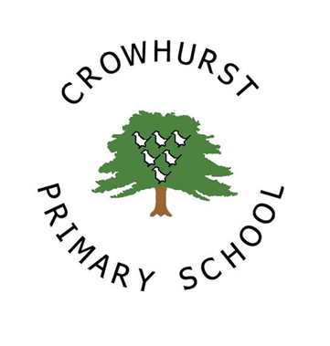

Approved by Governors | 11.6.25
Last reviewed on: | 11.6.25
Next review due by: | July 2028

Our vision

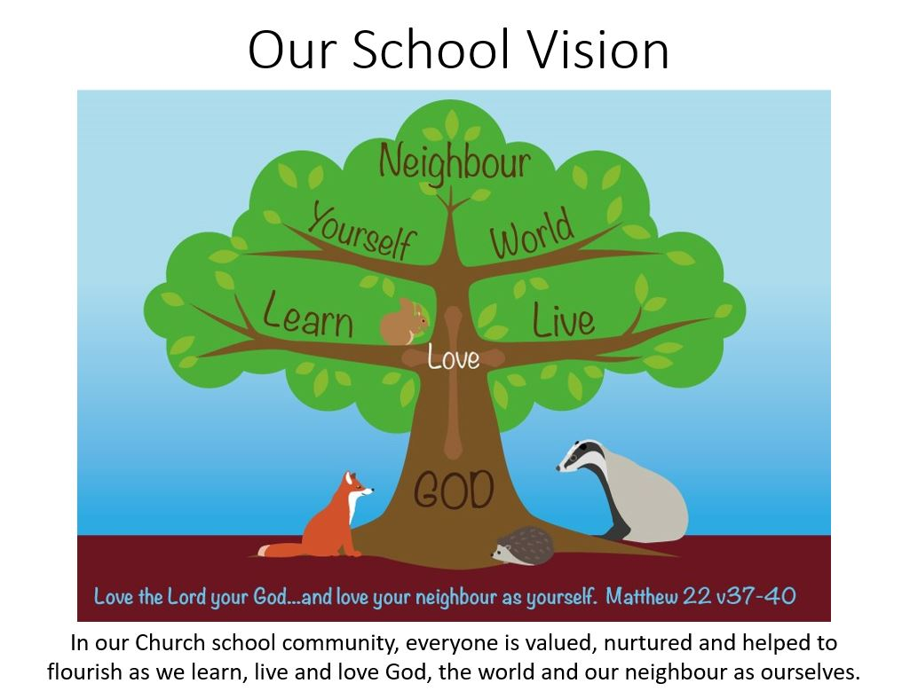

At Crowhurst CE Primary School we have an uncompromising commitment to valuing each member of our school community just as God values each one of his children. We recognise that both children and staff bring something special to the school and our job is to find it, nurture it and celebrate it.

We are of the opinion that if we learn to love ourselves, God, our world and our neighbours then we will help to improve our community and the world around us. We will achieve this through:

- ‘Living out’ our Christian values.
- Nurturing a passion and thirst for learning.
- Building relationships with each other.
- Empowering one another to face life’s challenges
- Modelling how to be active and responsible members of the community

Everyone has something of value to offer and our hope is that as a school with staff, children, parents, and governors working closely together, we can be a positive influence in our community and in our world.

Aims and objectives
1.1 Religious education enables children to investigate and reflect on some of the most fundamental questions asked by people. At Crowhurst CE Primary School we develop the children’s knowledge and understanding of the major world faiths, and we address fundamental questions concerning, for example, the meaning of life and the existence of a divine spirit. We enable children to develop a sound knowledge not only of Christianity but also of other world religions. Children reflect on what it means to have a faith and to develop their own spiritual knowledge and understanding. We help the children learn from religions as well as about religions.

1.2 The objectives of teaching religious education in our school are to help children:

- develop an awareness of spiritual and moral issues arising in their lives;
- develop knowledge and understanding of Christianity and other major world religions and value systems;
- develop an understanding of what it means to be committed to a religious tradition;
- be able to reflect on own experiences and develop a personal response to the fundamental questions of life;
- develop an understanding of religious traditions and to appreciate the cultural differences in Britain today;
- develop investigative and research skills, and make reasoned judgements about religious issues;
- have respect for other people’s views, and celebrate the diversity in society.

The legal position of religious education

2.1 Our school curriculum for religious education meets the requirements of the 1988 Education Reform Act (ERA). The ERA stipulates that religious education is compulsory for all children, including those in the reception class who are less than five years old. The ERA allows parents to withdraw their child from religious education classes if they so wish, although only after they have given written notice to the school governors. The ERA also allows teachers to refuse to teach religious education, but only after they have given due notice of their intention to the school governors. The religious education curriculum forms an important part of our school’s spiritual, moral and social teaching. It also promotes education for citizenship and community cohesion. Our school RE curriculum is based on the Leicester Diocesan Board of
Education’s Syllabus which includes ‘Religious Literacy for All’ and ‘Understanding Christianity’. The ERA states that the RE syllabus should reflect the fact that religious traditions in Great Britain are in the main Christian, and that it should, at the same time, take account of the teachings and practices of other major religions.

Teaching and learning style

3.1 We base our teaching and learning style in RE on the key principle that good teaching in RE allows children both to learn about religious traditions and to reflect on what the religious ideas and concepts mean to them. Our teaching enables children to extend their own sense of values, and promotes their spiritual growth and development. We encourage children to think about their own views and values in relation to the themes and topics studied.

Our teaching and learning styles in RE enable children to build on their own experiences and to extend their knowledge and understanding of religious traditions. We use their experiences at religious festivals to develop their religious thinking. We organise visits to local places of worship, and invite representatives of local religious groups to come into school and talk to the children.

3.2 Children carry out research into religious topics. They study particular religious faiths and also compare the religious views of different faith groups on topics such as rites of passage or festivals. Children investigate religious and moral issues either individually, in pairs or in groups.

3.3 We recognise the fact that all classes in our school have children of widely differing abilities, so we provide suitable learning opportunities for all children by matching the challenge of the task to the ability of the child. We achieve this in a variety of ways, for example, by:

- setting tasks which are open-ended and can have a variety of responses;
- setting tasks of increasing difficulty;
- grouping the children by ability in the room, and setting different tasks for each ability group;
- providing resources of different complexity, adapted to the ability of the child;
- using adults to support or enrich the work of individuals or groups of children.

Curriculum planning in religious education

4.1 We plan our religious education curriculum in accordance with the Diocesan B of E Syllabus ‘Religious Literacy for All’ as well as ‘Understanding Christianity’. We ensure that the topics studied in religious education build on prior learning. We offer opportunities for children of all abilities to develop their skills and knowledge in each unit, and we ensure that the progression planned into the scheme of work offers the children an increasing challenge as they move through the school.

4.2 The long-term RE plan maps the religious education topics studied in each term. The RE area of learning leader devises this plan in collaboration with teaching colleagues in each year group. We teach religious education topics in conjunction with other subjects.

4.3 Our medium-term plans give details of each unit of work for each term. The class teacher writes the plans for each lesson and lists the specific learning objectives and expected outcomes.

The Foundation Stage

5.1 We teach religious education to all children in the school, including those in the reception class.

5.2 In our reception class, religious education is an integral part of the topic work covered during the year. As the reception class is part of the Foundation Stage of the National Curriculum, we relate the religious education aspects of the children’s work to the objectives set out in the Early Learning Goals which underpin the curriculum planning for children aged three to five.

Contribution of RE to the teaching in other curriculum areas

English

Religious education contributes significantly to the teaching of English in our school by actively promoting the skills of reading, writing, speaking and listening. Some of the texts that we use in English have religious themes or content.

Personal, social, health and economic education and citizenship

Through our religious education lessons we teach the children about the values and moral beliefs that underpin individual choices of behaviour. So, for example, we contribute to the discussion of topics such as smoking, drugs and health education. We also promote the values and attitudes required for citizenship and community cohesion in a democracy by teaching respect for others and the need for personal responsibility. In general, by promoting tolerance and understanding of other people, we enable children to appreciate what it means to be positive members of our pluralistic society.

Spiritual, moral, social and cultural development

Through religious education in our school we provide opportunities for spiritual development. Children consider and respond to questions concerning the meaning and purpose of life. We help them to recognise the difference between right and wrong, through the study of moral and ethical questions. We enhance their social development by helping them to build a sense of identity in a multicultural society. Children explore issues of religious faith and values and, in so doing, they develop their knowledge and understanding of the cultural context of their own lives.

6.4 British Values

Many of the British values are studied explicitly as religious and non-religious concepts across the key stages in RE. We enjoy learning about different faiths and cultures from around the world. We promote diversity through celebrations of different faiths and cultures. We aim to foster mutual respect through structured debate and discussion. Children are encouraged to question and explore sensitive and controversial issues, whilst maintaining tolerance and respect for the views and beliefs of others. The RE curriculum is focused on understanding the beliefs and world-views of different people and through understanding, true tolerance develops. Members of different faiths are welcome in our school and are encouraged to share their knowledge with us. We enjoy visiting and learning about places of worship from different faiths.

RE and inclusion

7.1 At our school we teach religious education to all children, whatever their ability and individual needs. Religious education forms part of the school’s curriculum policy to provide a broad and balanced education to all children. Through our religious education teaching we provide learning opportunities that enable all pupils to make good progress. We strive hard to meet the needs of those pupils with special educational needs, those with disabilities, those with special gifts and talents, and those learning English as an additional language, and we take all reasonable steps to achieve this.

7.2 When progress falls significantly outside the expected range, the child may have special educational needs. Our assessment process looks at a range of factors – classroom organisation, teaching materials, teaching style, differentiation – so that we can take some additional or different action to enable the child to learn more effectively. This ensures that our teaching is matched to the child’s needs.

7.3 We enable all pupils to have access to the full range of activities involved in religious education. Where children are to participate in activities outside the classroom for example, visits to places of worship, we carry out a risk assessment prior to the activity, to ensure that the activity is safe and appropriate for all pupils.

Assessment for learning

8.1 Children demonstrate their ability in RE through a variety of different ways. Teachers will assess children’s work in religious education by making informal judgements as we observe them during lessons. On completion of a piece of work, the teacher assesses the work and gives the child written or verbal feedback to help guide progress. Children are encouraged to make judgements about how they might improve their work in the future. This information is used to assess the progress of each child, for setting new goals, and for passing information on to the next teacher and the RE leader at the end of the year.

Resources

9.1 We have sufficient resources in our school to be able to teach all our religious education teaching units. We keep resources for religious education in a central store where there is a box of equipment for each unit of work. There is a set of bibles for both key stages, and a collection of religious artefacts which we use to enrich teaching in religious education. The school library has a good supply of RE topic books.

Monitoring and review

10.1 The RE leader is responsible for monitoring the standards of the children’s work and the quality of the teaching in religious education. S/he is also responsible for supporting colleagues in their teaching, for being informed about current developments in the subject, and for providing a strategic lead and direction for RE in the school. The leader presents the headteacher with an annual report which evaluates strengths and weaknesses in the subject and indicates areas for further improvement. S/he has specially-allocated time for carrying out the vital task of reviewing samples of the children’s work and visiting classes to observe teaching in the subject.

