Crowhurst C of E Primary School

Collective Worship Policy


Approved by Governors | 11.6.25
Last reviewed on: | 11.6.25
Next review due by: | July 2028
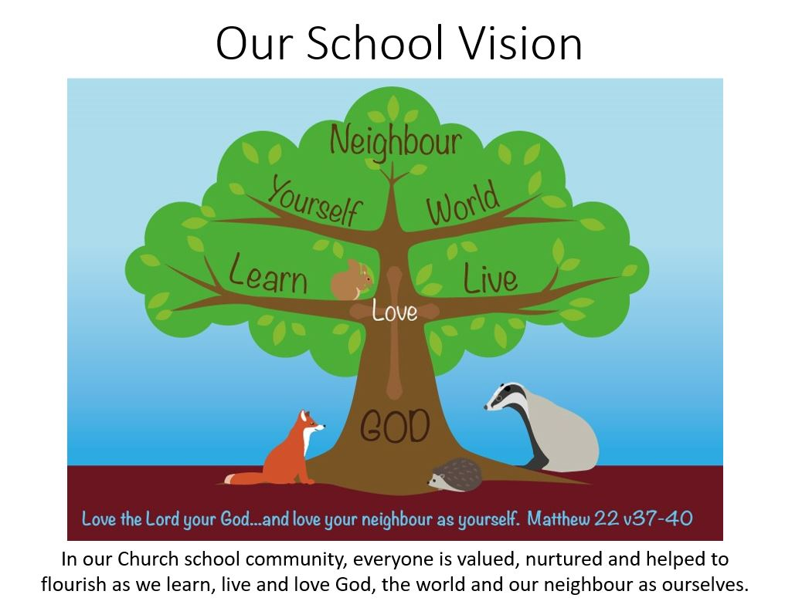
In our school our Christian vision shapes all we do.
‘Collective Worship in a Church school should enable every child and adult to flourish and to live life in all its fullness. (John 10:10). It will help educate for wisdom, knowledge and skills, hope and aspiration, dignity and respect, and developing community and understanding of living well together.
Policy Statement
In Crowhurst CE Primary School worship is central to the life of school and is the main platform for exploring the school’s vision. It is well planned and of high quality so that the whole school community is engaged on a journey of discovery, exploring the teachings of Jesus and the Bible.
For Christians in Church, worship is about honouring God and responding to the loving nature of God as revealed through the Trinity: Father, Son and Holy Spirit. A school is not a Church but is a collection of people who come from a variety of backgrounds for the purpose of education. The family backgrounds may be very different and collective worship must take account of the varied circumstances of staff and pupils.
At Crowhurst CE Primary School collective worship aims to be inspirational, invitational and inclusive and will lead people to a threshold where they can witness worship and join in, if they wish.
Through Collective Worship pupils will be offered a space and a place for the telling of the Christian story. They will be offered an understanding of worship through being invited to participate in or observe prayer, reading and reflection on the Bible, liturgy, sacrament and experience of the musical and other imaginative riches of Christianity. Opportunities to reflect on the beauty, joy and pain of the world will be given. Pupils will be given time to consider their responsibilities to others and to grow in love and service. Time will be given for celebration, both for the accomplishments of school members and to mark the seasonal festivals of the Christian (and other faiths) calendar. Pupils will be offered time to be able to contemplate and develop spiritually.

Church of England Guidance
Collective worship policy at Crowhurst CE Primary School) draws on guidance from the Church of England . This guidance document has been produced to challenge, to guide and set expectations for Church school communities and diocesan authorities, encouraging them to reflect on their practice and to ensure that collective worship remains the relevant and essential component of an education that enables all pupils to flourish.
Legal Requirements
There must be a daily act of collective worship in all maintained schools for all pupils, other than those in a nursery class or a nursery school. This can take place at anytime in the school day and in any groupings. Collective worship in a Church of England School must be in accordance with the tenets and practices of the Church of England. In other words the law on collective worship that applies in a community school, “that it should be wholly or mainly of a broadly Christian character”, is not relevant.
The governing body school have the responsibility for ensuring that the school meets the requirements for worship detailed in the Statutory Inspection of Anglican and Methodist Schools (SIAMS) Evaluation Document. They are also tasked with monitoring and evaluating the impact of worship on the school community in consultation with the headteacher.

The right of withdrawal

In Crowhurst CE Primary School there are significant numbers of children whose families are members of another faith, or who hold a non- religious world view. Part of the distinctively Christian nature of Church of England Schools is that they should be as hospitable and inclusive to all in the community they serve. As collective worship occupies such a central place in the life of the Church school, this should be made clear on induction, and it is hoped that parents will be making a specific choice of the school knowing that the distinctive ethos will determine a Christian tradition within collective worship.
The 1944 and1988 Education Acts state that parents have the right to withdraw children from collective worship and suitable arrangements should be made to accommodate these children.
On occasions, a parent may make a request for their child to be withdrawn from Collective Worship. There is an expectation that parents wishing to request a withdrawal will meet with the headteacher to discuss their concerns and requirements. It may be helpful to establish:
- The elements of worship in which the parent would object to the child taking part
- The other aspects of school life that are impacted by the Christian foundation of the school such as prayer and reflective areas
- The practical implications of withdrawal
- Whether the parent will require any advanced notice of such worship, and if so, how much

Where parents have withdrawn their children from collective worship and request religious worship according to their particular faith or denomination, the governors and head teacher will seek to respond positively to such requests providing:
- Such arrangements can be made at no additional cost to the school
- That the alternative provision would be consistent with the overall purposes of the school curriculum as set out in the Education Acts

If the Parent asks that a pupil should be wholly or partly excused from attending any religious worship at the school, then the school must comply.
(This means that a parent may, for example, request their child does not take part in a carol service when otherwise the child takes part in daily collective worship.)

Guiding Principles

Collective worship in Crowhurst CE Primary School aims to:

- Have a pivotal place in the life of the school.
- Support pupils and adults in their spiritual growth
- Be the central vehicle by which the school’s vision is unpacked and explored so that the whole school community is challenged and engaged with the teachings of Jesus and the Bible.
- Provide an experience of worship that will offer opportunities for those present to observe and/or respond to the presence, power and peace of God as understood by Christians. This will always be invitational, offering an opportunity to take part whilst allowing the freedom for those of other faiths and none to be present with integrity.
- Support pupils in the development of their understanding of the Trinitarian nature of God in Christian belief
- Provide a variety of different opportunities for reflection, understanding of diverse liturgical traditions, participation, challenge and enjoyment where all present can be actively involved and develop their own spirituality whilst contributing to the communal journey.
- Help children to become familiar with Christian language and symbolism and the cycle of the Church year so that they are offered a pattern of meanings and a framework into which they can begin to integrate experience.
- Explore a variety of ways of praying, giving children the opportunity to form their own prayers using multi-sensory foci and introduce them to some well know Christian prayers, as well as a variety of prayers of thanksgiving before mealtimes and home time.
- Offer opportunities to all children and staff to develop their skills in planning, leading and evaluating the impact of school worship with the support and shared engagement of the local church community. Pupils will be at the centre of this process taking on increasingly independent roles in planning and leading worship.
- Ensure that materials and themes for worship are carefully selected to make sure pupils understand the work of Christians and the church locally, nationally and globally and how this reflects the teachings of the Bible and the example of Jesus.

Development of the policy and links to other policies and documentation
We ensure that the principles for collective worship are reflected and applied in our policies and practice including those that are concerned with:
- Pupils’ personal development and wellbeing
- SMSC and PSHE
- Staff recruitment, retention and professional development
- Care, guidance and support
- Behaviour, discipline and exclusions
- Working in partnership with parents, carers and guardians
- Working with the wider community
We also ensure that information about collective worship is included in the school prospectus and / or on the school website.

How Collective worship is organised

Leadership
- The Headteacher organises the plan for leadership of Collective Worship as shown in Appendix 1. This may include the Headteacher, Teachers, Teaching Assistants, members of local Clergy or suitably vetted visitors.
- Visitors leading worship are supported and guided through briefings with the Headteacher.

Planning
- Plans for Collective Worship are developed by the Headteacher, in line with the school’s values
- These plans ensure worship reflects the cycle of the Church year
- Worship is carefully planned to ensure Christian values of the school are identified, expressed and celebrated through collective worship
- Explicit links are made between Bible stories and the Christian values of the school
- A pattern for worship is used which reflects Anglican tradition e.g. opening and closing worship with liturgy such as The Lord be with you / And also with you, Go in the peace of Christ / Thanks be to God
- A range and variety of materials are used, including: Big Start Assemblies, videos, websites, artefacts, stories, drama scripts, artwork, music, songs, film clips,
- The worship table will include focal points e.g. a cross, Bible and candle
- Collective worship provides opportunities for children and adults to explore faith in today’s world
- Christian belief in the Trinitarian nature of God is explored and applied where this arises in worship
- Spiritual growth through prayer, stillness and reflection is nurtured as a result of Collective worship
Organisation
Collective Worship is organised to take account of:
- The different groupings for worship, including whole school/key stage/class worship
- The different settings and places for worship; how the worship space is made special; and how the atmosphere for worship is created using:
The liturgical colours of the seasons of the Church Year,
Christian signs and symbols, candles, music, a focal point,
Ritual and liturgical responses,
How the children are seated,
An outdoor area e.g. spiritual garden, the local church
- At what point in the school day worship is held and the amount of time allocated

Staff development and training
We ensure that all staff, including support staff, receive appropriate training and opportunities for professional development, both as individuals and as groups or teams.

Monitoring and evaluation
- The Headteacher and Governors monitor and evaluate the impact of worship
- Monitoring and evaluating the impact of worship is carried out by a range of individuals including children, staff, foundation governors, clergy

Disseminating the policy
We ensure that this policy is known to all staff and governors, parents and carers and, as appropriate, to all pupils. This policy is available on our school website.

Collective Worship in a CofE school must be in alignment with the religious foundation of the school (Christian), however there is a responsibility for schools in all contexts to mark, respond and learn from the festivals of other faiths. This may be designated as a separate act, not to be conflated with collective worship.
“To worship is to quicken the conscience by the holiness of God, to feed the mind with the truth of God, to purge the imagination by the beauty of God, to open the heart to the love of God and to devote the will to the purpose of God”. William Temple (1881-1894)
https://www.churchofengland.org/about/education-and-schools/church-schools-and-academies/collective-worship

